Testing document for MS Decom activities

Project: Z_3F9F_QTML_GR

System : xFE

CD: 151938.

Transport request: DFEK962733

—---------------------------------------------------------------------------------------------------------------------------------

1. External Cross Test Kit Report exporting into my Drive.

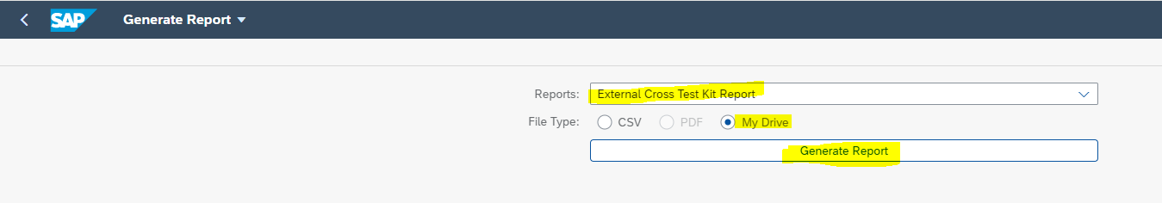

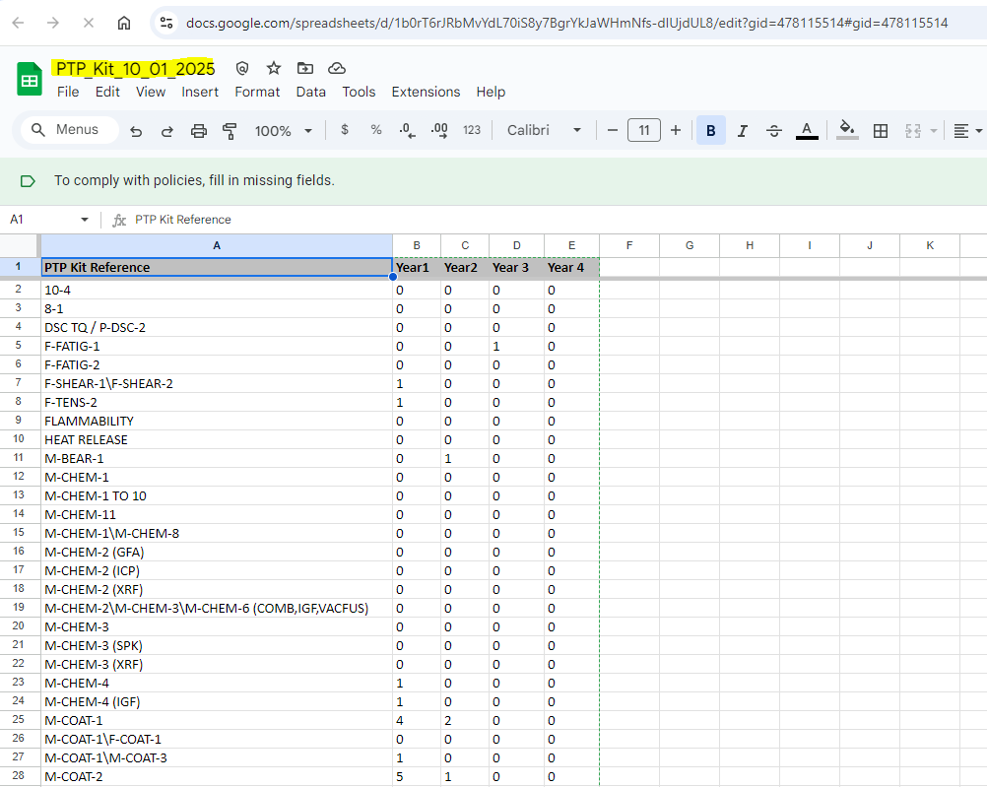

1. External Report Independent

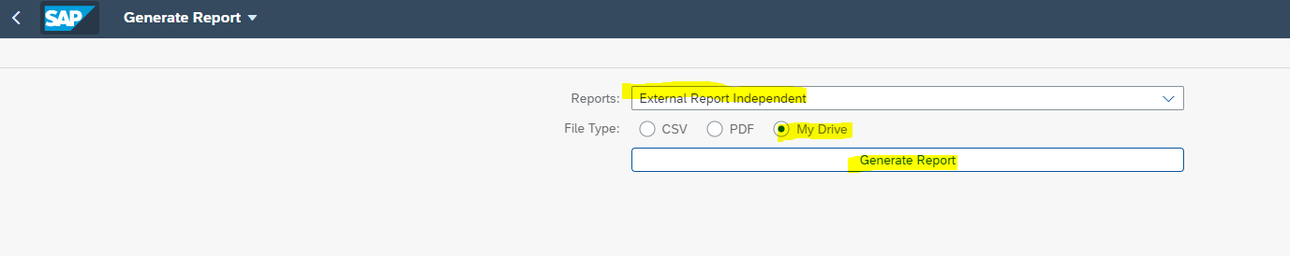

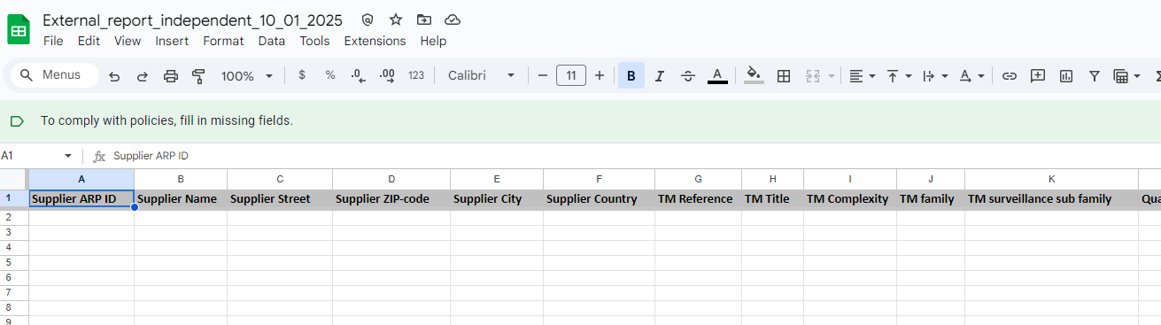

1. External Report Captive:

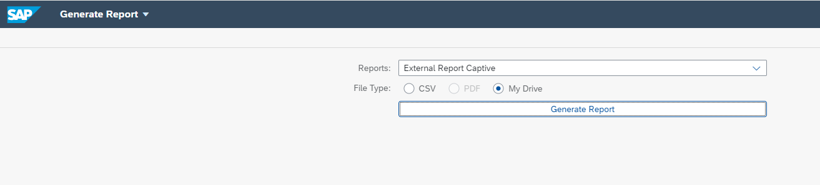

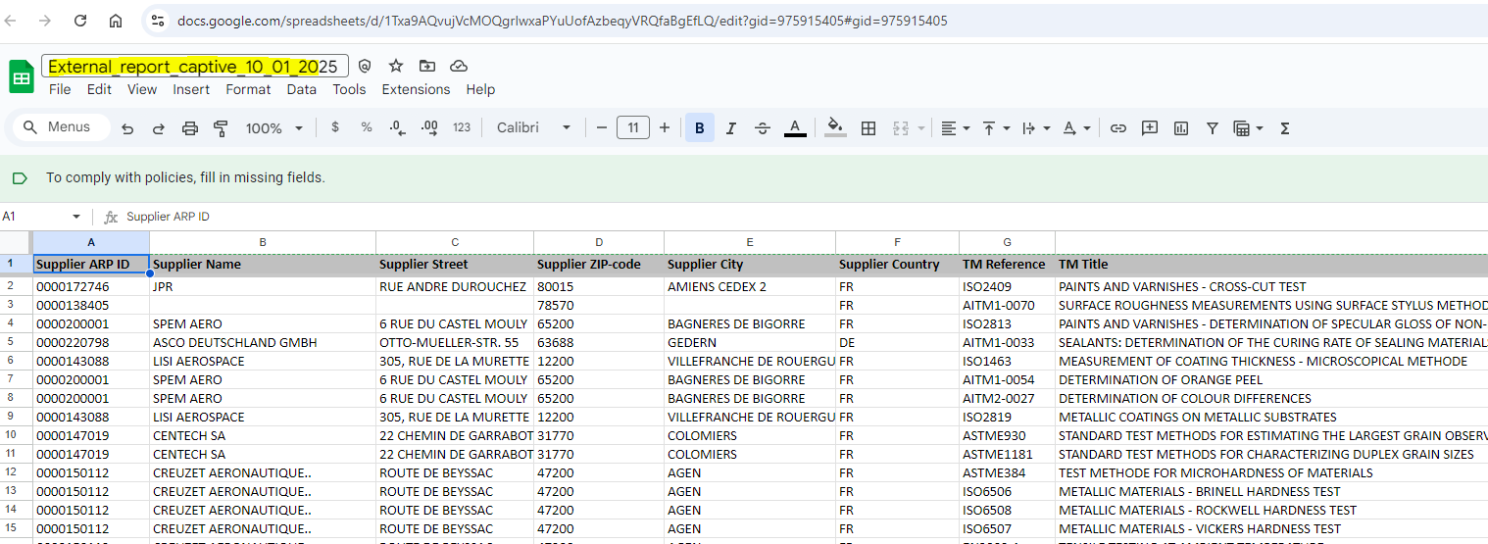

1. Internal Report Captive/Independent:

